Unit 8: Quadratics and roots
Lesson 3: Quadratics in vertex form
Objectives:
- I can identify the vertex form of a quadratic
- I can change the vertex form to standard form or factored form of a quadratic
Agenda:
- Quiz
- Video
- Practice
Focus Questions:
- How can we change the quadratic vertex form to standard form or factored form?
- How can I identify the vertex looking the quadratic vertex form quadratic?
Vocabulary:
- Perfect Square, factored form, standard form, Vertex form

Homework: HW 8-4
Online support:
- https://www.youtube.com/watch?v=jGJrH49Z2ZA Fun

https://www.youtube.com/watch?v=xGOQYTo9AKY

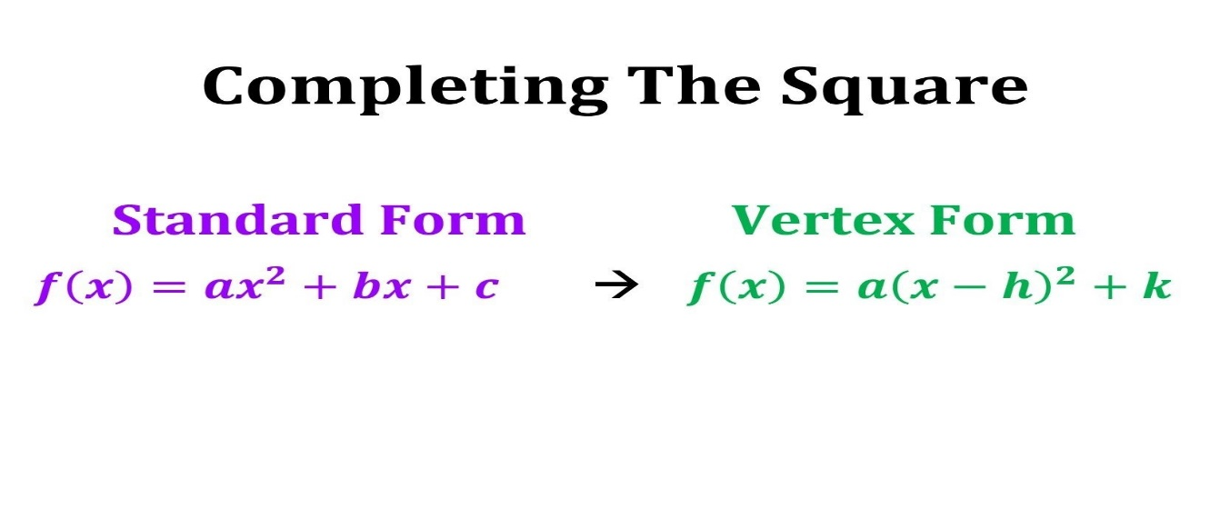

Do Now:

Given the following graph of a parabola, answer the following:

- list the roots: ____ ____________________________
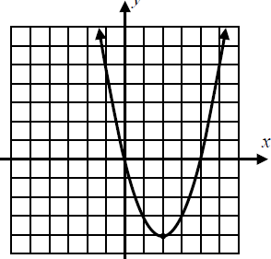
- What is the Axis of Symmetry: _________________________

- What is the Vertex?_______________Max or Min

- The formula to find the axis of symmetry is: _______________________

Factoring Feb:

- Which is a factor of x² + 5x – 24?
- (x + 4) 3. (x – 4)
- (x + 3) 4. (x – 3)

- One of the factors of 4x² – 9 is
- (x + 3) 3. (2x + 3)
- (4x – 3) 4. (x – 3)

- Factor: $2x^{2}- x-3$
- $(2x-3)(x +1)$
- $(x-1)(2x-3)$
- $(2x + 1)(x-3)$
- $(x-1)(2x-3)$

- Sketch each of the following quadratics and use a table of value to find the coordinate of the turning point (vertex) from the calculator.

$f\left(x\right)={\left(x-3\right)}^{2}+2$ $H\left(x\right)= -x^{2}+8 x+11$

Solve by taking the square root:

- ${ x}^{2}=16$ | 2)${ (x+3)}^{2}=36$
3)${ x}^{2}=49$ | 4)${ (x-1)}^{2}=15$
Vertex Form vs Standard form: https://www.youtube.com/watch?v=jGJrH49Z2ZA
Steps for Completing the Square using the vertex form

1. Check if the coefficient of the quadratic is one.
If it is not, divide each term by that value to create a leading coefficient of one. This include negative.
2. Rewrite your quadratic in the standard form.
3. Prepare to add the needed value to create the perfect square trinomial. Be sure to balance the equation. The boxes may help you remember to balance. | 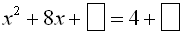
4. Take half of the coefficient of the middle term (x-term), square it, and add that value to both sides of the equation to keep the equation balanced.  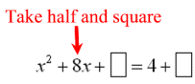 | 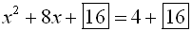
5. Factor the perfect square trinomial.
6. Solve by taking the square root?

Follow the Exact steps from the notes above: Examples: Solve each example by completing the square.
- $x^{2}-2x=10$ 2. $x^{2}+2 x=3$

3. ${ x}^{2}=-2x+8$ 4. $f\left(x\right)=x^{2}-4x-5$

Name: ____________ Algebra I
Homework 8-3 Vertex form
- Write each of the following quadratic into vertex form. Then, identify the coordinates of its turning point.

a) b) $x^{2}-10x+24=0$

- A goalie kicks a soccer ball with an upward. The quadratic function
$h (t)= -16t^{2}+ 65t +1$, represents the height of the ball h in feet after t seconds

- What is the highest distance the ball travels?

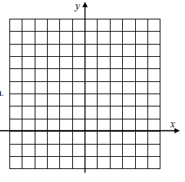
- At what time does the ball reaches that height?

- Calculate the equation for the axis of symmetry algebraically.

